🚀 BizJump Incorporation Website Upgrade

Project Objective: Revamp current checkout process for an incorporation business

https://www.bizjump.com/service/incorporation/

Project Description
The BizJump Incorporation Platform is a guided, WooCommerce-based business formation system designed to allow entrepreneurs to form a business online through a structured, step-by-step wizard. The platform mirrors the user experience of leading incorporation providers while maintaining transparent flat-rate pricing and customizable service options.
The system replaces traditional consultation-based incorporation services with a productized workflow where users select their entity type, state of formation, and optional services, then complete checkout. After purchase, the platform captures all required business formation details and routes the order for processing.

Similar to the ones on these sites:
  - https://www.legalzoom.com/business/business-formation/?openChat=true
  - https://www.zenbusiness.com/
  - https://bizee.com/

Platform Features

Guided Wizard Interface
Step-by-step onboarding flow that simplifies incorporation.

Productized Service Packages
Four service tiers:
- Basic
- Pro
- Premium
- Enterprise
Each tier includes different levels of service.

Add-On Service Selection
Users can select optional services that dynamically update pricing.

Dynamic Pricing Logic
Pricing changes based on:
- entity type
- state fees
- selected services
- subscription options

Subscription Services
Recurring billing for:
- Registered Agent
- Website hosting
- compliance monitoring

WooCommerce Checkout
Secure payment via:
- Stripe
- PayPal
- ACH

Client Dashboard
Customers can:
- view order status
- upload documents
- track progress
- download deliverables

Admin Order Management
BizJump team can:
- view formation details
- track services purchased
- update status
- manage subscriptions

Technology Stack
- Platform: WordPress
- E-commerce Engine: WooCommerce
- Wizard Builder: CartFlows
- Product Configuration: WooCommerce Product Add-ons
- Subscriptions: WooCommerce Subscriptions
- Checkout Customization: Checkout Field Editor
- CRM Integration: FluentCRM or Jetpack CRM
- Hosting: WP Engine / Kinsta / SiteGround

🚀 BizJump Incorporation Detailed Workflow (WooCommerce-Based)

🔧 I. Suggested Tools & Plugins Overview

Purpose | Plugin | Function
E-commerce Core | WooCommerce | Enables product listings, checkout, and order processing
Service Tiers & Add-ons | WooCommerce Product Add-ons or Advanced Product Fields (APF) | Adds conditional logic for business types, EIN, etc.
Subscriptions (Enterprise Plan) | WooCommerce Subscriptions | Enables $29/month recurring support & update billing
Document Uploads | WooCommerce Checkout Add-ons or Checkout Files Upload | Collects Articles, ID, EIN authorization, etc.
CRM & Email Follow-up | Jetpack CRM or FluentCRM | Manages onboarding, drip campaigns, and customer engagement
Client Dashboard | Custom My Account Page or WP Adminify | Allows users to track progress and manage documents
Legal Pages | WP Legal Pages | Generates privacy policy, TOS, and refund policy
Hosting | Kinsta / SiteGround / WP Engine | Optimized hosting for WooCommerce performance

📦 ✅ Use Product Add-ons for visual feature indicators
✅ Use Compare Table Block (Gutenberg or Elementor) for plan comparison

Checkout Workflow

Summary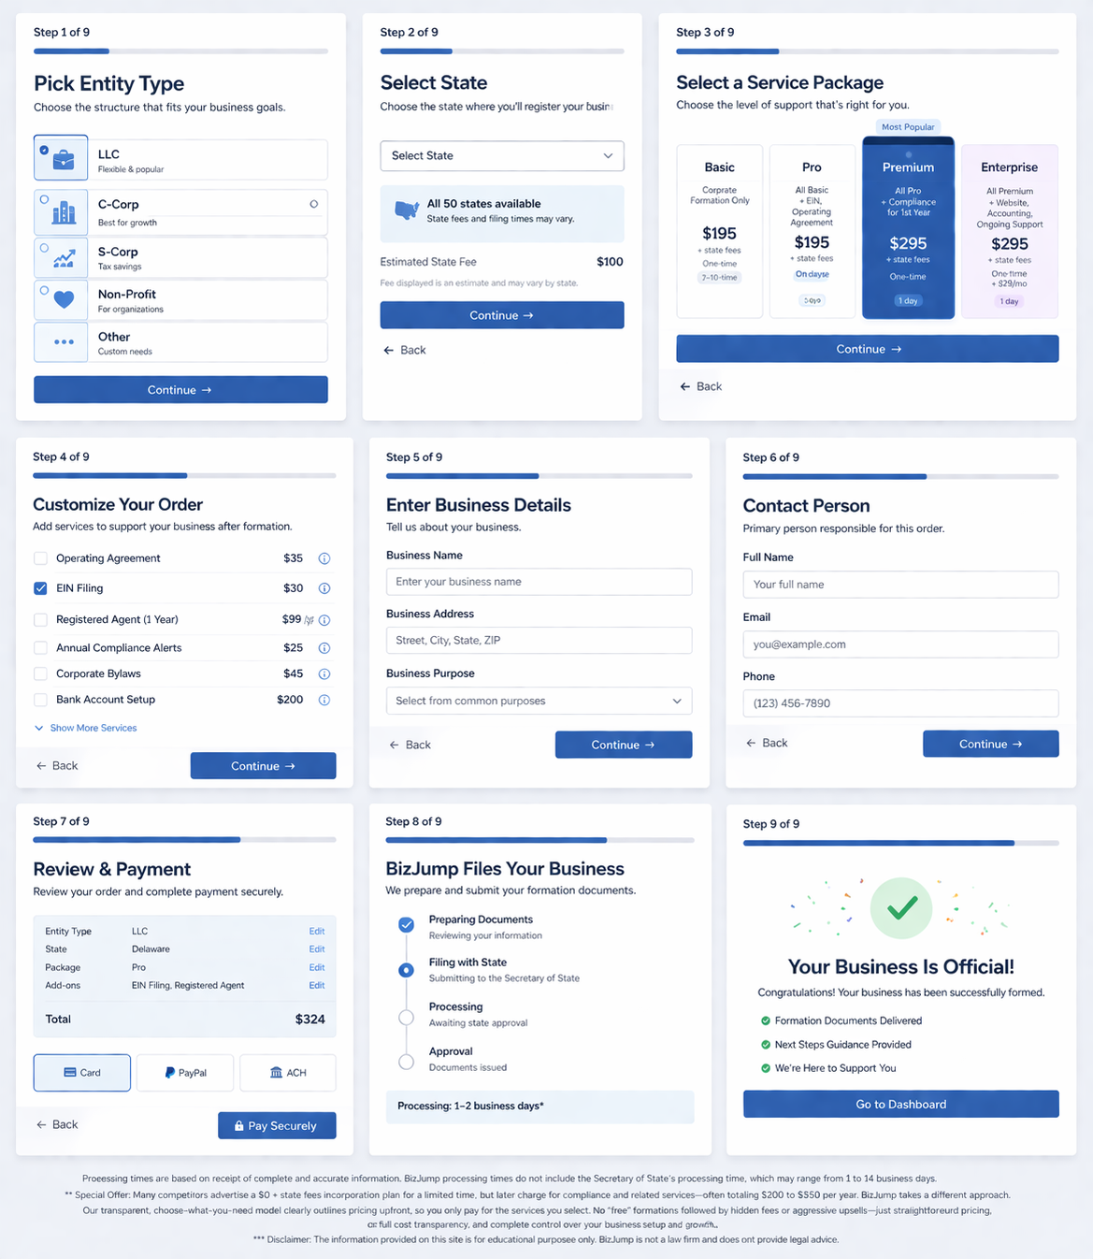

Detail Steps for Designer

🔹 Step 1: Select Entity Type
Add a dropdown menu:
- LLC
- C-Corp
- S-Corp
- Non-Profit
- Other (redirect to a short form for custom quote)
✅ Use Advanced Product Fields (APF)

 | Suggested Example |  | https://bizee.com/

Let's start with your new business
Dream Big. We’ll Handle the Small but Critical Stuff.
1. Pick Entity  - LLC  - C-Corp  - S-Corp  - Non-Profit  - Other |  | 2. Select State  - All 50 states

🔹 Step 2: Select State
- Dropdown of all 50 U.S. states
- Dynamically show state-specific filing fees
✅ Optional: Use state fee lookup logic or conditional pricing

🔹 Step 3: Select Services-
Let users select service level
II. Service Package Structure
Create 4 WooCommerce Simple or Variable Products:

Plan | Price | Includes
Basic  Corporate Formation Only  Ideal for DIY entrepreneurs who can handle all post incorporation & other startup and compliance tasks themselves | $99 +  state fees  One-time payment | Corporate Filing Only (7–10 days)
Pro  All Basic Features +  Ideal for entrepreneurs who want us to handle all initial filings & startup issues including filing Tax id (EIN) | $195 +  state fees  One-time payment | Corporate Filing +, EIN, Operating Agreement (5 days)
Premium  All Pro Features +  manage ongoing compliance tasks for 1st year | $295 +  state fees  One-time payment | Rush Corporate Filing + EIN , Operating Agreement, Compliance docs templates (1 day)
Enterprise  All Premium Features +  Perfect for businesses seeking ongoing support, accounting setup, web presence, and monthly updates | $295 +  state fees  One-time payment  (then $29/monthly) | Premium Corporate Filing + free website, domain, premium support, accounting system setup (1 day). Ongoing hosting & website maintenance & support
- Processing times are based on receipt of complete and accurate information. BizJump processing times do not include the Secretary of State’s processing time, which may range from 1 to 14 business days.
- Special Offer: Many competitors advertise a $0 + state fees incorporation plan for a limited time, but later charge for compliance and related services—often totaling $200 to $350 per year. BizJump takes a different approach. Our transparent, choose-what-you-need model clearly outlines pricing upfront, so you only pay for the services you select. No “free” formations followed by hidden fees or aggressive upsells—just straightforward pricing, full cost transparency, and complete control over your business setup and growth.
- Disclaimer: The information provided on this site is for educational purposes only. BizJump is not a law firm and does not provide legal advice.

Suggested Example | 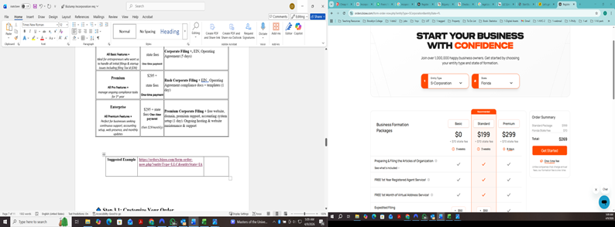 | https://orders.bizee.com/form-order-now.php?entityType=LLC&entityState=IA

🔹 Step 3.1: Customize Your Order

Add services that support your business after formation

Service | Price | Customer Description (hidden but hover for more) | WooCommerce Logic / Implementation
Operating Agreement | +$35 | Legal document defining ownership, roles, and management structure of your LLC. Often required by banks. | Checkbox add-on. Show when Entity Type = LLC. Hide if Pro or Premium already includes it.
EIN Filing | +$30 | We obtain your IRS Employer Identification Number for banking, payroll, and taxes. Required for most business entities. | Checkbox add-on. Show for all entities. Auto-select if Pro or Premium plan selected. Allow user to uncheck.
Registered Agent | +$99/year | We receive legal notices and state correspondence on your behalf and forward them to you. | Subscription checkbox add-on. Hide if Enterprise selected. Add recurring yearly billing.
Annual Compliance Alerts | +$25 | Email reminders for annual reports, deadlines, and required filings. | Checkbox add-on. Hide if Premium or Enterprise plan selected.
Corporate Bylaws | +$45 | Governing rules for corporations including officers, meetings, and voting. | Checkbox add-on. Show only if Entity Type = C-Corp or S-Corp.
Corporate Shareholder Agreement | +$95 | Defines shareholder rights, ownership transfers, and dispute resolution. | Checkbox add-on. Show only if Entity Type = C-Corp or S-Corp.
Bank Account Setup | +$200 | Assistance opening your business bank account with required documentation. | Checkbox add-on. Always available. No conditional logic.
IRS Form 2553 – S-Corp | +$35 | File IRS election for S-Corporation taxation (pass-through taxation). Owners must be U.S. citizens or residents. | Show when Entity Type = LLC or C-Corp. Auto-select when user chooses S-Corp taxation. Hide if already included in plan.
Executive Corporate Kit | +$99 | Professional binder with seal, stock certificates, and corporate documents. | Checkbox add-on. Show for LLC, C-Corp, and S-Corp. Optional.
Accounting System Setup & Tax Planning | +$25 | Setup accounting structure and provide basic tax planning guidance. | Checkbox add-on. Always visible. Optional.
First Year Corporate Tax Filing (CPA) | +$195 | CPA prepares and files first-year business tax return (60–70% discount). Personal taxes separate. | Checkbox add-on. Show when Entity Type ≠ Nonprofit.
Corporate Website (5 pages) | Free + $29/month | Professional 5-page website with hosting and management. | Checkbox add-on with subscription. Add $0 setup + $29 monthly recurring if selected.
Digital Marketing Setup | +$95 | We create and configure your business social media accounts and Google business profile so you're ready to attract customers immediately. Includes: Facebook, Instagram, LinkedIn, YouTube, Google Business, Analytics, | Checkbox add-on. Always visible. Optional.
IRS EZ-501(c)(3) Filing | +$395 | Preparation and submission of nonprofit tax-exempt application. | Checkbox add-on. Show only when Entity Type = Nonprofit.

- ✅ Add via WooCommerce Product Add-ons
✅ Enable dynamic price updates at checkout

🔹 Step 4: Enter Business Details
Use Checkout Field Editor to collect:
- Business Name | - Select from on of these designators  - For C-Corp, S-Corp. Not for Profit  - INC  - CORPORATION  - INCORPROATED  - CORP  - For LLC  - LLC  - LIMITED LIABILITY COMPANY
Your official company name will display as
BIZJUMP INC

What if company name is unavailable?
We will contact you with guidance in choosing other options

- Business Purpose
- Business Address

🔹 Step 4.1: Enter Contact Person Details

Contact Person
Please provide the name of the person responsible for this order whom we may contact if additional information is needed.
- First Name
- Last Name
- Email
- CONTACT ADRESS (Same as Business Address?)

- Mobile Phone
- United States +1
- I consent to receiving SMS text messages and phone calls from BIZJUMP

- Optional document uploads
✅ Use WooCommerce Checkout Field Editor

Other Roles
At this stage, we only require contact information for the person responsible for setting up the corporation. Depending on the selected service level, we may later request contact information for owners/shareholders, directors, and officers.

🔹 Step 5: Review & Payment
- Display summary with all selections and pricing
- Payment Methods:
  - Stripe
  - PayPal
  - ACH via Stripe plugin
✅ Show estimated processing time based on plan

🧑‍💼 IV. Post-Purchase Automation
Action | Implementation
Admin notified of full order | WooCommerce backend + file uploads
Client receives confirmation & timeline | WooCommerce email templates
Client dashboard access | Customize “My Account” section
Document upload/download | Customer dashboard plugin
Subscription management | Via WooCommerce Subscriptions plugin
CRM-based follow-up | Automate with Jetpack CRM or FluentCRM

🛡️ V. Legal & Compliance Setup
- Include:
  - ✅ Privacy Policy
  - ✅ Terms of Service
  - ✅ Refund Policy
- Generate via WP Legal Pages or manual draft
- Ensure:
  - ✅ SSL Certificate
  - ✅ Google reCAPTCHA protection

📊 Optional Enhancements
Feature | Recommended Plugin
Order Progress Tracker | Custom Order Status Tracker plugin
Testimonials Slider | Strong Testimonials or Elementor widget
Dynamic Pricing Table | Pricing Table by Supsystic or TablePress

✅ Summary: What This Workflow Enables
- Productize your incorporation services using WooCommerce
- Customize plans with logic-driven add-ons and state/entity fields
- Streamline checkout for transparency and speed
- Automate admin and CRM processes post-purchase
- Deliver a branded dashboard experience for client interaction

